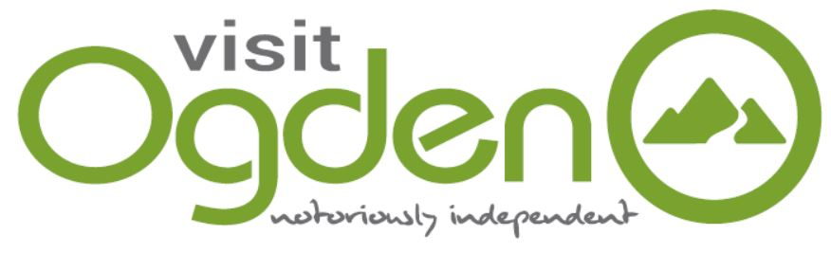
Community Partnerships Manager
Visit Ogden

Visit Ogden is a non-profit organization tasked with working with the people and places of our community to sustainably curate, cultivate, and promote meaning experiences for residents and visitors. We are the county’s official destination management organization.

POSITION PURPOSE: To build and maintain relationships with individuals, organizations, and partners that support Visit Ogden’s goals. Secure Visit Ogden’s reputation and role as a “community good” by providing and communicating value to industry stakeholders and residents. Ensure group visitors are aware of activities and have an opportunity to engage in the community.

REPORTS TO: President/CEO, but is also accountable to the DOS, DOMC, Board of Trustees, Visit Ogden partners and stakeholders.

PRINCIPAL ACTIVITIES:
- Develop a strategy to build and maintain programs and activities that will have a positive impact on the community through stakeholder and community engagement.
- Build and maintain relationships with businesses, individuals, community groups and other relevant organizations within the industry.
- Conceptualize and determine opportunities to engage in additional DEIA initiatives or programs.
- Develop a Marketing Partnership Program (DDP 1.33). Manage program sales, implementation, execution, and partner reporting to provide value to stakeholders and revenue opportunities for Visit Ogden.
- Be the conduit to facilitate opportunities and best working relationships between lodging properties and Visit Ogden.
- Work with lodging property partners to provide valuable information to in-market groups and guests including an action plan for communication with single property groups. Work to activate groups with community engagement opportunities while in-market including group activities, and community events. Goal is to engage groups into the community enough to encourage repeat business.
- Gather venue and lodging calendar information and community event information for Visit Ogden newsletter to share with stakeholders for effective planning and communication with visitors.
- Encourage partners to share Hot Deals, group promotions (ie Bandwango) or other relevant and pertinent information to be shared with visitors.
- Manage communication of logistics of familiarization tours and site inspections with hotels, restaurant, and attraction partners.
- Manage communication of logistics and activation information for campaigns that require community partner support ie Pledge for the Wild, Ogden Restaurant Week, etc.
- Conceive, plan, and facilitate logistics of business development and marketing education programs (DDP 1.26). Work with ODA or other relevant partners to identify needs and promote opportunity.
- Compile and maintain business partner email distribution list(s), website listings and CRM information.
- Support business and workforce development partners and needs.
- Oversee relocation information availability on website, social and/or printed materials and coordinate providing quality of life information to city, county, and/or other economic development partners.
- Determine appropriate and worthwhile data to share with partners including options such as visitor data, website analytics, and social media engagements.
- Develop Bring It Home/Keep It Local campaign details and work with community partners to implement.
- Work with preservation groups to support preservation of and find ways to provide interpretive signage for historic places (DDP 1.34).
- Serve as the Film Commissioner for Weber County in support of the Utah Film Commission.
- Serve as a key point of contact for neighboring businesses, institutions, and communities.
- Be an ambassador for the organization with responsibilities for delivering the company’s vision within the local community.
- Identify additional community partnership and development opportunities to further DDP initiatives or other strategies.

MEASUREMENT STANDARDS:
- Revenue generated from Marketing Partnership Program.
- Number of community “activations” and campaigns requiring partner support.
- Hosting a minimum of one business training opportunity per quarter.
- Reported successful and positive relationships and interaction with hospitality community partners.
- Successfully planned fam tours and site inspections.
- Identify opportunities for new programming or initiatives including DEIA opportunities.
- Quantity and quality of Bring It Home/Keep It Local business booked.
- Completes work within established deadlines.
- Be knowledgeable of Weber County venues, attractions, lodging, and entertainment and act as a Weber County ambassador in all areas.

Note: This job description is not intended to be all-inclusive. Employee may perform other related duties as defined to meet the ongoing needs of the organization.

